Deployment of Flask Application on Heroku(Web App and API)

Name: Harshith Sakala Santhosh

Batch code: LISUM19

Submission date: 04-04-2023

Dataset used: Breast Cancer Dataset

Model Used: Logistic Regression

Deployed Platform: Heroku

Links to access:

1. Web App: https://breast-cancer-heroku-app.herokuapp.com/
2. API(through Post-Man): https://breast-cancer-api-deployment.herokuapp.com/breast_cancer_prediction?radius_mean=17.99&texture_mean=10.38&perimeter_mean=122.80&area_mean=1001.00&smoothness_mean=0.118&compactness_mean=0.277&concavity_mean=0.3001&concave_points_mean=0.147&symmetry_mean=0.241&fractal_dimension_mean=0.087&radius_se=1.09&texture_se=0.90&perimeter_se=8.58&area_se=153.400&smoothness_se=0.006&compactness_se=0.049&concavity_se=0.05&concave_points_se=0.015&symmetry_se=0.03&fractal_dimension_se=0.006&radius_worst=25.33&texture_worst=17.33&perimeter_worst=184.6&area_worst=2019.00&smoothness_worst=0.1622&compactness_worst=0.665&concavity_worst=0.711&concave_points_worst=0.26&symmetry_worst=0.460&fractal_dimension_worst=0.1189.

Steps to deploy flask application

1. Model training using Logistic Regression and Breast Cancer Dataset

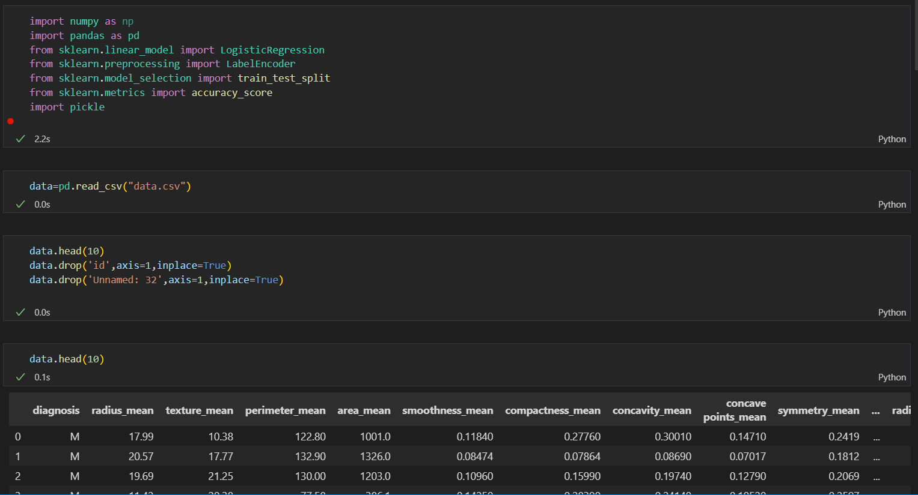

1. Requirements File

For Web App Deployment

For API Deployment

1. Proc File

For Web App Deployment

For API Deployment

1. HTML Code and Page

5)Code For API Development

Fast API code(App.py):

REQUEST FILE FOR SENDING API REQUEST

1. Post-Man Endpoint for API Testing

1. Pickle file in Project Folder:

